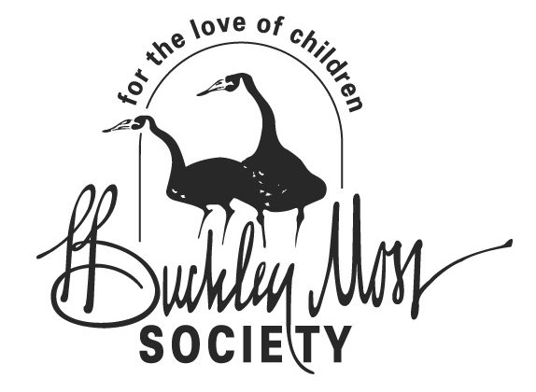 | CHARITY PRINT COLLECTION  DONATION REQUEST FORM  P. Buckley Moss Society  74 Poplar Grove Lane  Mathews, VA 23109 Ph: (800) 430-1320  Ph: (804) 725-7378  Email: charityprints@pbuckleymoss.com |  |  |  |  | Form #  1 | BOX FOR OFFICE USE
 |  |  |  |  |  | Form #  1 | Type or print clearly.  Please allow 3-6 weeks for processing
CONTACT PERSON (Person responsible for print and follow-up paperwork) |  |  |  |  |  |  | EMAIL
ORGANIZATION NAME |  |  |  |  |  |  | SHIPPING ADDRESS (for artwork if approved, no PO Box)
ADDRESS |  |  |  |  |  |  | SHIPPING LINE 2
CITY |  |  |  | STATE | ZIP |  | SHIPPING CITY, STATE ZIP
WORK PHONE  ( ) |  |  |  | HOME PHONE  ( ) |  |  | FAX  ( )
Benefiting Organization
ORGANIZATION TO BENEFIT FROM FUNDRAISER |  |  |  |  |  |  | TAX STATUS  ___ Exempt: Tax ID #____________________  ____ Non-Exempt: indicate reason:

PURPOSE OF ORGANIZATION

DONATION WILL BENEFIT ___ Children’s Health / Welfare ____ Learning Disadvantaged __ Other (please describe)

INDICATE SPECIFIC PROGRAMS TO RECEIVE FUNDS

Fundraising Event
EVENT NAME (if applicable) |  |  |  |  |  |  | TYPE OF EVENT  ___ Raffle ___ Live Auction ___ Silent Auction
LOCATION CITY & STATE |  |  |  |  |  |  | DATE (a specific date must be provided. e.g. drawing date for raffle)
MARKETING / PROMOTION PLAN

Additional Information to Support Request
Are you working with a P. Buckley Moss Society Chapter? ___ Yes ___ No |  |  |  |  |  | Are you working with a Moss Dealer in your area? ___ Yes ___ No
CHAPTER NAME |  |  |  |  |  | DEALERSHIP NAME
CHAPTER CONTACT |  |  |  |  |  | DEALER ADDRESS CITY & STATE
COMMENTS

$20 Processing Fee |  | We require payment for a processing fee of $20 ($10 for local pickup). If your request is denied your payment will not be processed. If a check is sent, and it does not clear, a $25 fee will be charged. This processing fee is non-refundable.
PAYMENT TYPE  __ Check __ Credit Card |  |  | CREDIT CARD NUMBER |  |  |  |  | EXPIRATION DATE

Name on Card: ___________________________________________ Signature: _____________________________________________________________ Date: ______________

Pat’s own charitable foundation, the P. Buckley Moss Foundation for Children’s Education, is able to provide its programs thanks to the generous support of people like you. Please indicate here if you would like to donate 10% of the funds received from your P. Buckley Moss print to the P. Buckley Moss Foundation:
I pledge 10% of funds raised from this donation to the P. Buckley Moss Foundation for Children’s Education.

